**Comments on RHNA 6th Allocation Inventory and Analysis**

**for Carmel Valley Master Plan Area of Unincorporated Monterey County**

The Carmel Valley Association, while respecting the pressing need for more sub-market housing in Carmel Valley, finds that the current RHNA Site Inventory and Analysis does not address consistency with the Carmel Valley Master Plan of 2010 and the Settlement Agreement of 2012. As our area currently accounts for one-fifth of the unincorporated County’s total obligation, we felt it appropriate to provide these detailed comments and suggestions.

We find that the provisions in the Inventory and Analysis for over 260 high end single family homes out of 590 in the overall allocation for the CVMP area show a lack of depth of study in developing the supply of sub-market rate housing. We have plenty of single family high end homes here, with active turnover in the high end real estate market; we need more affordable housing for teachers, firefighters, and many other tradespeople who often drive long distances to work here.

We recognize that finding sites that meet State RHNA guidelines while upholding local Land Use Plans is a challenge. We’re willing to help in recommending some alternatives that will require prompt review and assessment for any inclusion or substitution for the current county efforts to complete the Regional Housing Needs Allocations (RHNA) and AB 686’s mandate to affirmatively furthering fair housing (AFFH) in a timely way.

At least two of the sites of the current Inventory and Analysis draft encourage high-end large projects with many single family homes far away from centralized services, septic, and transportation and in "locations with high risk of flood or fire” that State guidelines seek to avoid; projects carried forward in these locations would both increase sprawl and greenhouse gas emissions. These selections also often put the precious remaining land of open space at the highest and lowest elevations in Carmel Valley at risk.

We are all faced with difficult choices here; CVA encourages additional diligence, creative thinking, and use of HCD Staff resources to provide workable allocations for the housing the State demands.

Comments on each site in the inventory follows, as we’ll as some suggested other properties and projects to research:

Site 27:

1. Appears very suitable and ready for multi-family apartment construction.

Site 28:

1. Has space, but a home already exists on this land. Will it count in the RHNA Allocation?

2. Why the 16 moderate here?

Site 29;

Same issues as site 28

Please see attachment # 1: screenshot of google map of sites 28 & 29 in appendix.

Site 30:

1. Is not on Carmel Valley Rd but also on Val Verde Dr,

2. Why 14 moderate? What not more multi-family apartments?

Site 31:

Same issues at site 30

Site 32:

1. Also not on Carmel Vally Road

2. A sacrifice of cultivatable land, but we understood the need to rezone and make multi-use due to its walkable placement at the mouth of the valley. A good location for more rental units.

2. Why the 16 moderate here?

Site 33:

1. This property above Del Mesa seems a good possibility, given adequate water and sewer.

2. 133 above moderate units would increase greenhouse gas emissions and add to the single family housing inventory in the valley. Perhaps considering affordable beyond the 20% Inclusionary guidelines could make more affordable units here.

3. More single family homes do not provide affirmatively further fair housing for working class families.

Sites 34 & 35:

1. These sites have drawn the most voluble complaints from our members and neighbors.

2. It appears that the two sites have been combined to provide more than twice the Inclusionary 20%. This could be positive, as long as the cost of connecting to long run to the Carmel Manor sewer line is factored in for any potential project(s) on these sites.

3. 54 affordable units seems a commendable densification of low density residential site, should that rezoning meet with the CVMP and Settlement agreements of 2012, but built right along Carmel Valley road as it would be, and across from a bucolic winery and event business and next to a rural horse barn could create many local issues on this one.

4. It sits in a high fire risk zone, has little existing infrastructure, and would increase greenhouse gases, and does not provide affirmatively further fair housing in the Valley.

Site 36:

1. This lot of record could accommodate more rental units than 2 units per parcel, if adequate sewer and water infrastructure could be found and the design incorporated all 4 parcels.

2. It is a poor choice for any units above moderate, as it sits between a gas station and a small office building on Dorris Dr..

3. How does one actually design a project to build quarter units?

4. Mid-Valley near the existing shopping center is a good location to meet RHNA allocations, but further diligence and creativity and contact to owners of lots of records would be required to adequately increase the housing inventory.

Site 37:

1. This site has a project in process for a storage unit.

2. Again, the need for water and adequate sewer connection could prevent any housing from going in here.

3. Mid-Valley near the existing shopping center is a good location to meet RHNA allocations, but further diligence and creativity and contact to owners of lots of records would be required to adequately increase the housing inventory.

Some suggestions of other places to look for suitable sites that would further RHNA goals and reduce the need for so many single family homes in this Inventory and Analysis:

Mouth of the Valley Area:

1. Explore the option of units that could take a small portion of parking spaces in the Shopping Centers for small affordable rentals at the mouth of the Valley.
2. Consider approaching owners of office space to convert to housing.
3. How about the lot in front of the fire station?
4. Contact CUSD about their large lot to the East of the soccer field and encourage them to join in this effort by dedicating a portion of it to creating affordable housing they could use to attract and retain teachers for the school system. Please see Appendix item #3.
5. Explore with State HCD the ability to include exiting inclusionary housing that are in current projects at Rancho Canada Village and September Ranch (Carmel One) currently under review.

Mid Valley area:

1. Explore options with the St. Phillips Lutheran Church across from All Saints School. A CVA Board member was approached by clergy at this church who are interested in adding affordable only housing on land they own behind their church. Please see Appendix #3 for screenshot of map.
2. Discuss sewer upgrade with Stanley Group and see if its new capacity would allow for denser infill of Site 36
3. Contact the owner of Site 37 and see if, given adequate access to water and sewer (see above), they might consider an alternate project that could include rental apartments for affordable housing walkable to the shopping center.

**APPENDIX**

1. Screenshot of Google maps of sites 28 & 29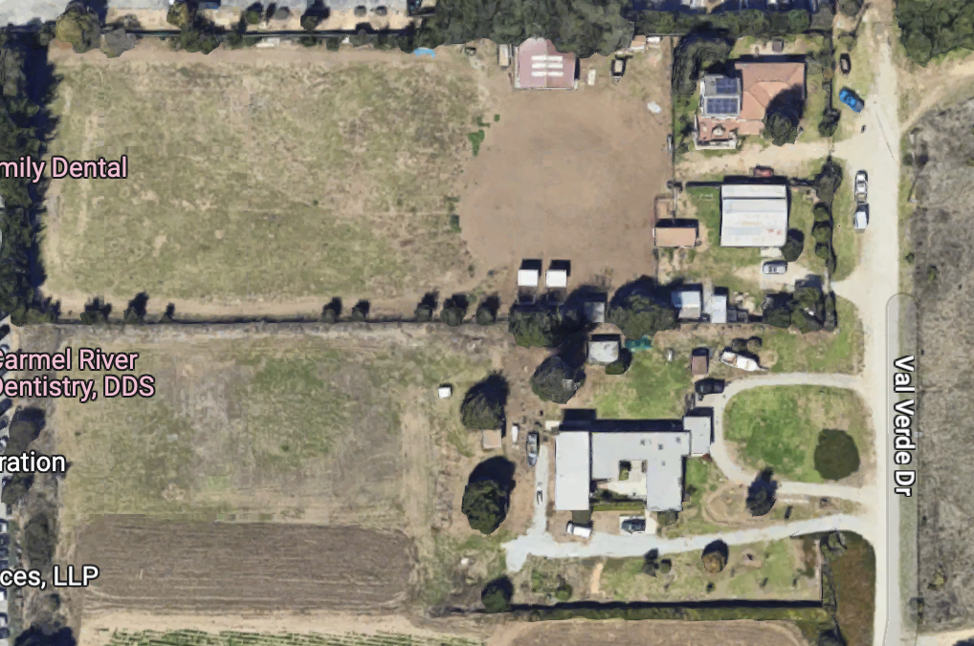
2. Screenshot of Google Map of Large Lot near CUSD Middle School

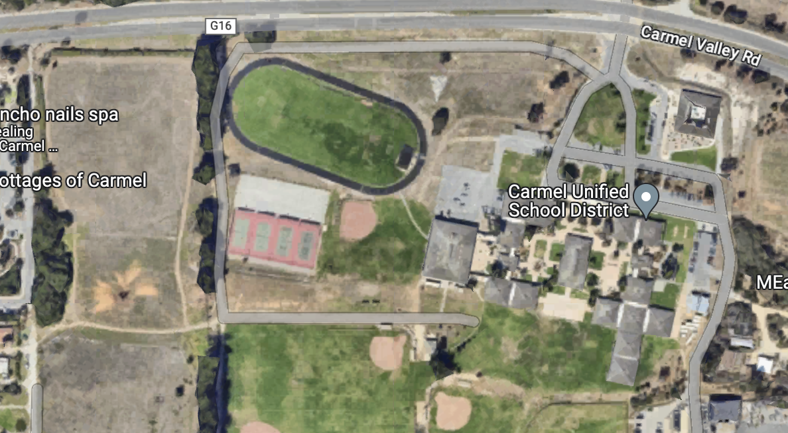

1. Screenshot of Google Map from St. Phillips Lutheran Church

